.NET Applications

Windows Forms (WinForms):

* Internal representation 🡪 C# code, C# object
* System.Web.Forms.Button
* Can’t take the behind code and put it into a web application
* Consists of files:
* Form1.cs
* – Form1.Designer.cs 🡪 [auto-generated?]
* – Form1.resx

WPF:

Two parts:

* XML 🡪 termed as XAML 🡪 read & rendered as the WPF UI
* Internal representation is XML; Enables 2 systems to communicate
* Allows you to write the application once in XML and then:

-render it on a Windows Platform – exe

-render it on a Win application

-run as Web Application in browser 🡪 Copy code in \to a WPF Browser Application

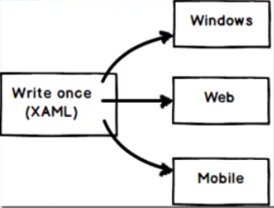

* WPF creates objects
* These objects will want to send/receive data to/from each other